|  |  |  |  |  |
| --- | --- | --- | --- | --- |
| Project: | Personal Tutoring Service  CSE 5325 – Fall 2013  Project Management | | | |
| Module: | Software Project Management | | | |
| Deliverable: | COCOMO Cost Estimation | | | |
| Version: | | [1.0] | Date: | [10/15/2013] |

Prepared by : Akshay Mattoo [1000995551]

Executive Summary

Personal tutoring service is an android based app which helps students to search for a tutor and the helps the tutor to market his/her skills. With the proper search criteria and the goggle maps being integrated in the app one can find a tutor. One can register or can enter as a guest user to search for the tutor. Once logged in a student can rate a professor on certain skills and that in turn can help the other incoming students judge the professor better. Notifications is also being integrated through emails, so that communications being there in between the interested users.

COCOMO Cost Estimation

COCOMO cost estimation contains the various cost factors that influence the cost of the project. For our project the cost factors are as below.

* Source line of code (SLOC) distribution.
* Cost of hardware and software used.
* Cost drivers and Scale drivers
* Salary components.

**SLOC distribution**:

Below is the table having the description about the distribution of number of lines of code for screens.

|  |  |
| --- | --- |
| **Component** | **Number of lines of code** |
| Login module | 475 |
| Register module | 565 |
| Search module | 660 |
| List view of tutor | 450 |
| Feedback/Rating for tutor | 695 |
| Google Map integration | 675 |
| Payment module | 465 |
| Advertising for tutor | 390 |
| Notification module | 415 |

***Total lines of code in the project are 4780.***

**Cost of hardware and software:**

|  |  |
| --- | --- |
| **Component** | **Cost in Dollars ($)** |
| Database | 0$ (MySQL open source) |
| Apache Server | 0$ (Apache Tomcat open source) |
| 6 Laptops | 2459.94$ |
| 1 Desktop | 129.99$ |
| Subversion control (SVN) | 0$ (open source) |
| Bug reporting tool | 0$ (Bugzilla open source) |
| Junit testing | 0$ (Integrated in android API) |
| 1 android mobile for testing | 383.88$ |
| 1 tablet for testing | 359.00$ |

***Total hardware cost: 3332.81$***

**Salary of the employees:**

Salary of each developer is 50$/hour and 50% overhead charge which boils down to 75$/hour. Salary of manager is 100$/hour and 50% overhead charge which boils down to 150$/hour. If we take the project start date as 9th Sep 2013 and end date as 9th Dec 2013.We have total days to be 92 days. All the 5 developers as well as manager will be billed for these many days.

Total cost of employees = [total no of developers *developer salary* no of hours * no of days]+[manager salary*no of hours*no of days]

=[5*75*8*92]+[150*8*92]=276000+110400=386400

***Total salary of developers and manager is 386400$***

**Scale Drivers:**

|  |  |  |
| --- | --- | --- |
| **Scale Driver** | **Selected** | **Reason** |
| PREC | High | Have made many android applications before and delivered successfully. |
| FLEX | High | Following agile development so change is inevitable. |
| RESL | High | Development in phases for overall risk is mitigated. |
| TEAM | Very high | Agile gives more stress on individuals and interaction |
| PMAT | Nominal | Basic processes are defined for incremental development. |

**Cost Drivers:**

|  |  |  |
| --- | --- | --- |
| **Cost Driver** | **Selected** | **Reason** |
| ACAP | Nominal | Agile development has skilled labour. |
| APEX | High | Agile has experienced labour. |
| PCAP | High | Agile has experienced and skilled labour. |
| PLEX | High | Have worked on android before. |
| LTEX | High | Have successfully delivered android projects before. |
| PCON | Nominal | Small organization with 1 project at a time. |
| TOOL | Nominal | Will use android SDK, Junit integrated in android for testing. |
| SITE | Extra High | Agile team are highly collaborative with more interaction |
| SCED | Very Low | Simple UI , database calls are done to insert and retrieve. |
| TIME | High | Not much of processing. |
| STOR | High | Simple iterations on database, server and network. |
| PVOL | Nominal | DB and OS changes are not required so frequent. |
| RELY | High | Failure doesn’t affect human life. |
| DATA | High | Insertion and updation of DB is tested. |
| CPLX | High | DB operations required for retrieval. |
| RUSE | Nominal | Iteration development .Not much of reuse. |
| DOCU | Very Low | Not much of documentation required n agile. |

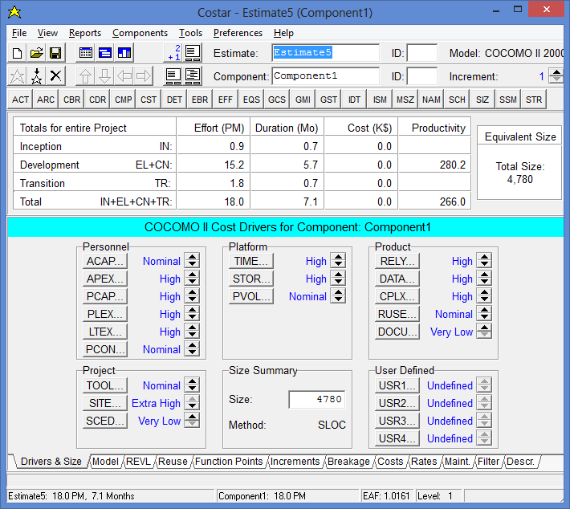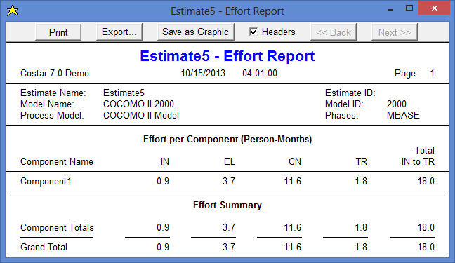

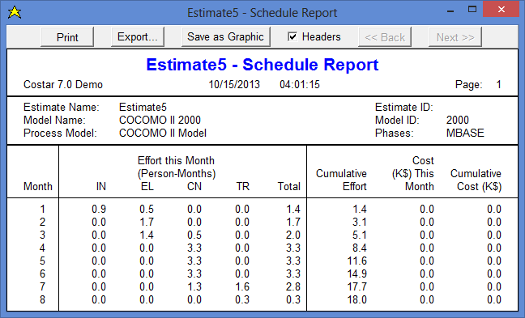

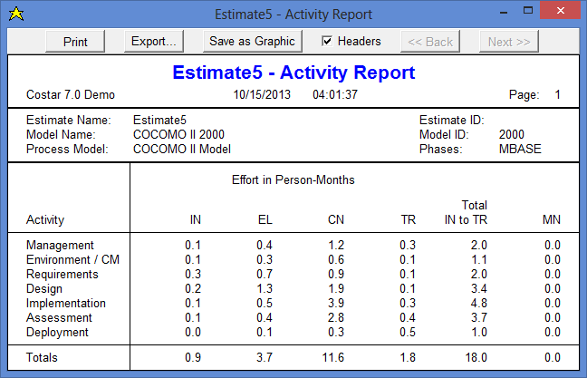

**Total estimated cost of project:**

Total estimated cost = [salary of employees]+[hardware and software cost]+[100% profit margin]

= [386400+3332.81]=[100%(386400+3332.81)] = [389732.81+389732.81]=779465.62

***Total projection cost of the project id 779465.65$***

Conclusion

The shift of trend in computing from Pc’s to laptop to smart phones and tablets made us to build the application on android platform which is an open source platform. The benefit of this app would be one can do things on the go.

References

Reference cost link for Database:

<http://dev.mysql.com/downloads/mysql/>

Reference cost link for Apache server:

<http://tomcat.apache.org/>

Reference cost link for desktop:

<http://www.amazon.com/Acer-S231HL-BBID-23-Inch-LED-Lit/dp/B00CRZCJKK/ref=sr_1_1?s=pc&ie=UTF8&qid=1381803017&sr=1-1&keywords=acer>

Reference cost link for laptops:

<http://www.amazon.com/Acer-E1-531-2686-Celeron-Processor-Windows/dp/B00CU2K7VI/ref=sr_1_8?s=pc&ie=UTF8&qid=1381803195&sr=1-8&keywords=acer+laptop>

Reference cost link for Android phone:

<http://www.amazon.com/Samsung-Galaxy-GT-I9300-Factory-Unlocked/dp/B007VCRRNS/ref=sr_1_3?ie=UTF8&qid=1381803606&sr=8-3&keywords=samsung+galaxy+s3>

Reference cost link for Android tablet:

<http://www.amazon.com/Samsung-Galaxy-Tab-10-1-Inch-White/dp/B00D029NNA/ref=sr_1_3?ie=UTF8&qid=1381803654&sr=8-3&keywords=samsung+tablet>

Reference Cost link for SVN:

<http://svnbook.red-bean.com/en/1.7/svn.intro.whatis.html>

Reference cost link for bug reporting tool:

<http://www.bugzilla.org/>

Reference cost link for the Junit for android:

<http://developer.android.com/reference/junit/framework/package-summary.html>